Identification de l’incident :

|  |  |  |  |
| --- | --- | --- | --- |
| **De :** | Agnes MAZAS |  |  |
| **Date** | 23/01/2020 | | |
| **Classification** | •MAM : Generated Audit / Manual Audit | | |
| **Reproductible : Yes** | | | |
| **Version IE** : IE 11.0.9600.18860CO | | | |
| **Version client 3D :** (Connexion au client 3D : touche shift+Ctrl+v) : VDC5.6.4. MAM.01.19.2020 | | | |

Steps to reproduce :

# Problem

Work order is completed during a validation in Manual Audit : in Manual Audit, when validate a server which is in a Generated_Audit for move work order, this server disapeared from list of devices validated and action “Equipment uninstall” is completed in work order in VDC.

# Steps to reproduce

There are two audits : Generated Audit_[WO AMA Move 25]_[158588] and Manual Audit “Manual_Audit_8”. Both are concerning server Srv_AMA_Move_25 and rack V3-D-08.

Generated Audit_[WO AMA Move 25]_[158588] is generated by submit a work order to move server from rack V3-D-08 to rack V3-D-09.

Manual_Audit_8 is a Manual Audit to audit rack V3-D-08.

## Create Manual_Audit_8

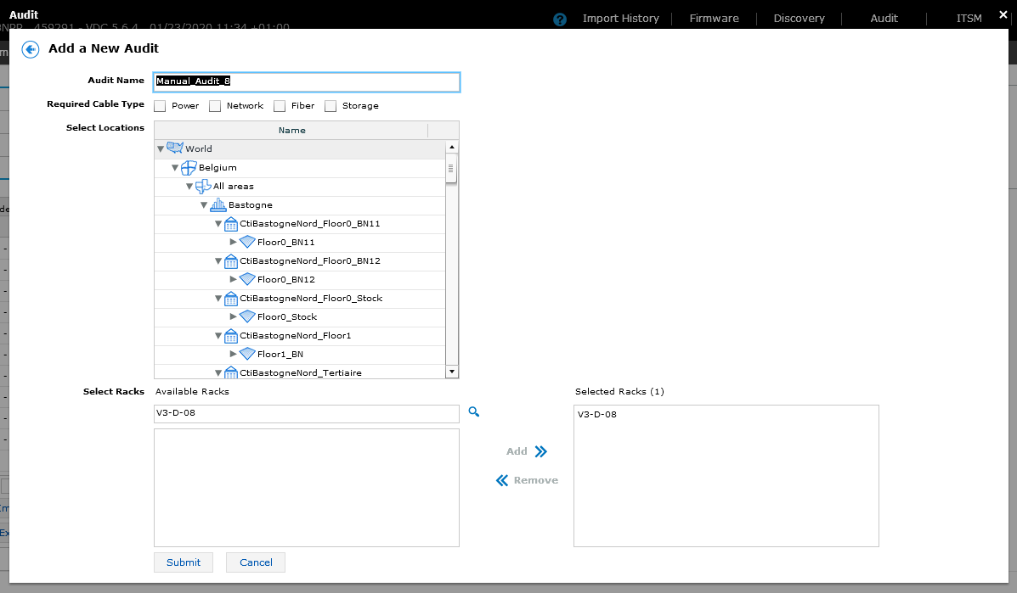

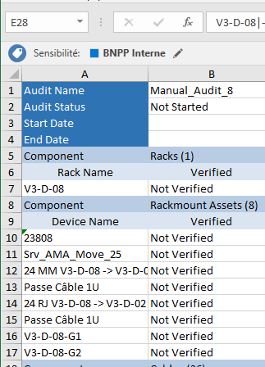

## Create Project Wizard

Create task to move Srv_AMA_Move_25 from rack V3-D-08 to V3-D-09 :

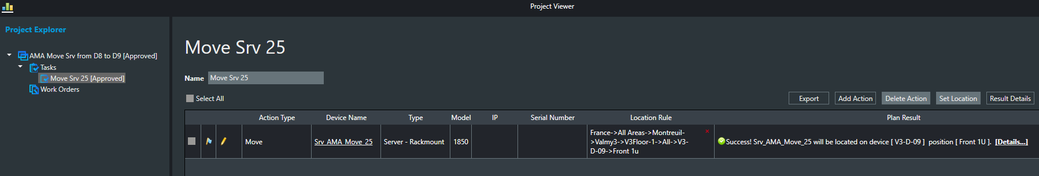

Create work order to move Srv_AMA_Move_25 from rack V3-D-08 to V3-D-09 :

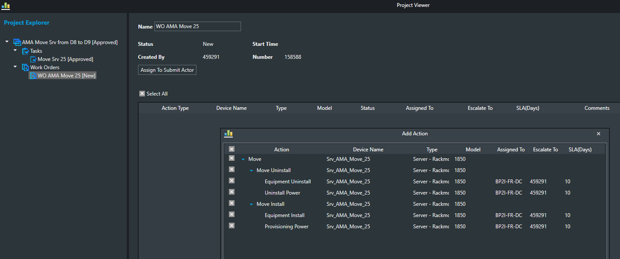

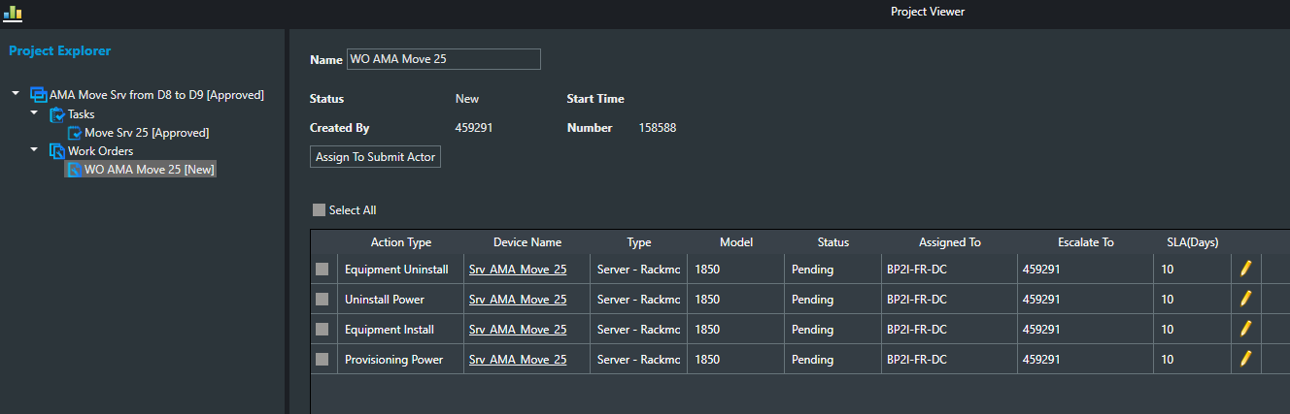

Submit work order and generate Audit Generated_Audit_[WO AMA Move 25]_[158588] :

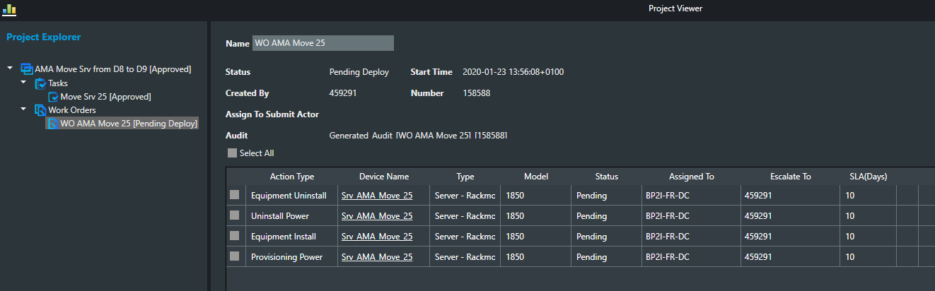

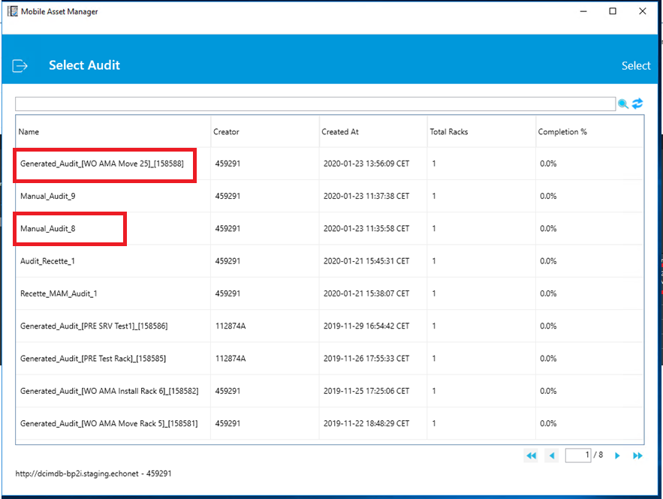

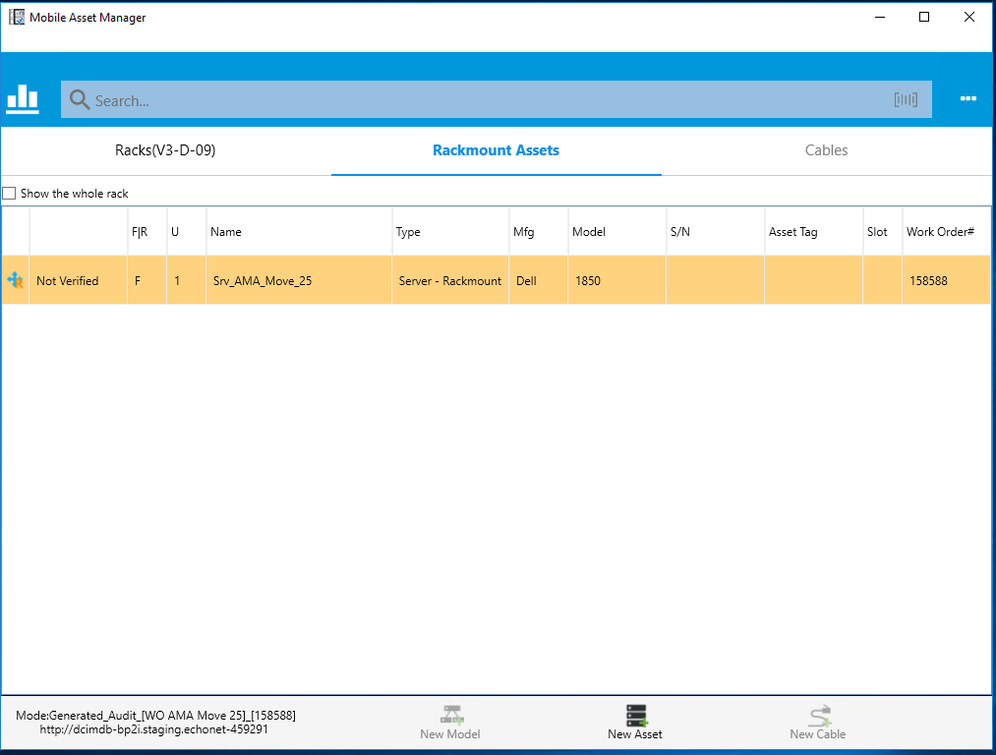

## Proceed to Audit Manual_Audit_8

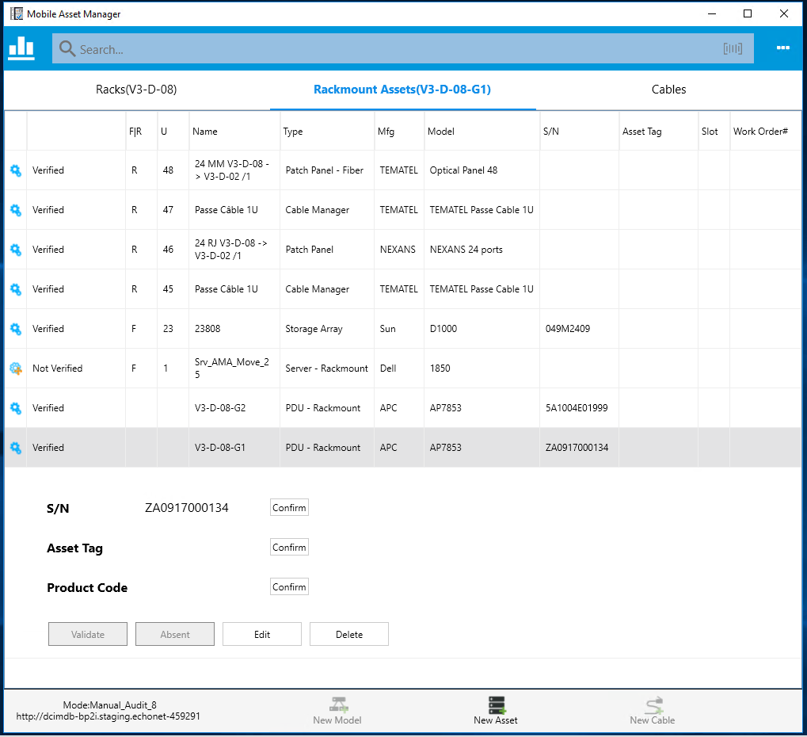

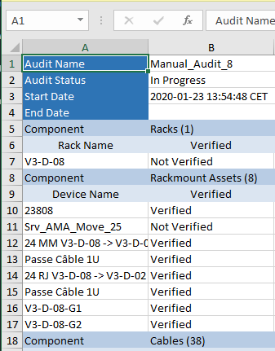

## Validate Srv_AMA_Move_25 from Manual_Audit_8

* Select Manual_Audit_8
* Select Srv_AMA_Move_25
* Validate Srv_AMA_Move_25

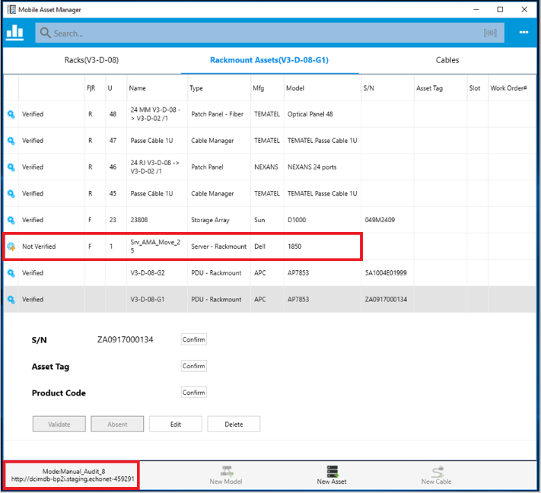

1/ Server Srv_AMA_Move_25 disapeared from the list of Manual Audit :

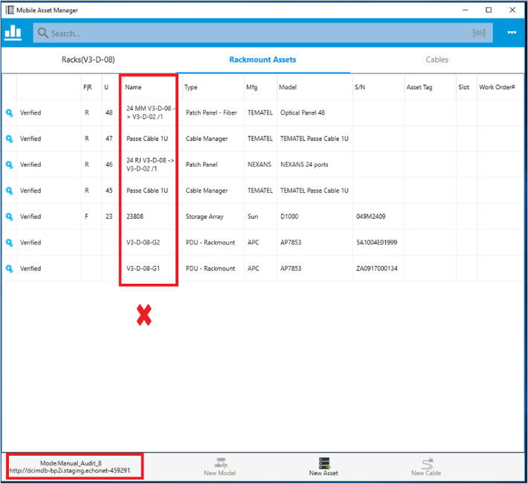

2/ Action Equipment Uninstall is completed in VDC :

